Newsletter 2019


2019

Welcome to NRG 2019

This year has seen us branch out into mobile apps with one for loading alignments and viewing sections and chainage of a project, another handy tool for displaying scale factor at current location and another for adding and managing attributes to pictures taken with the camera

We have also made long sections much easier to use and to develop reports with.

To accommodate the growing use of point clouds we have added support for pre-Georeferenced images

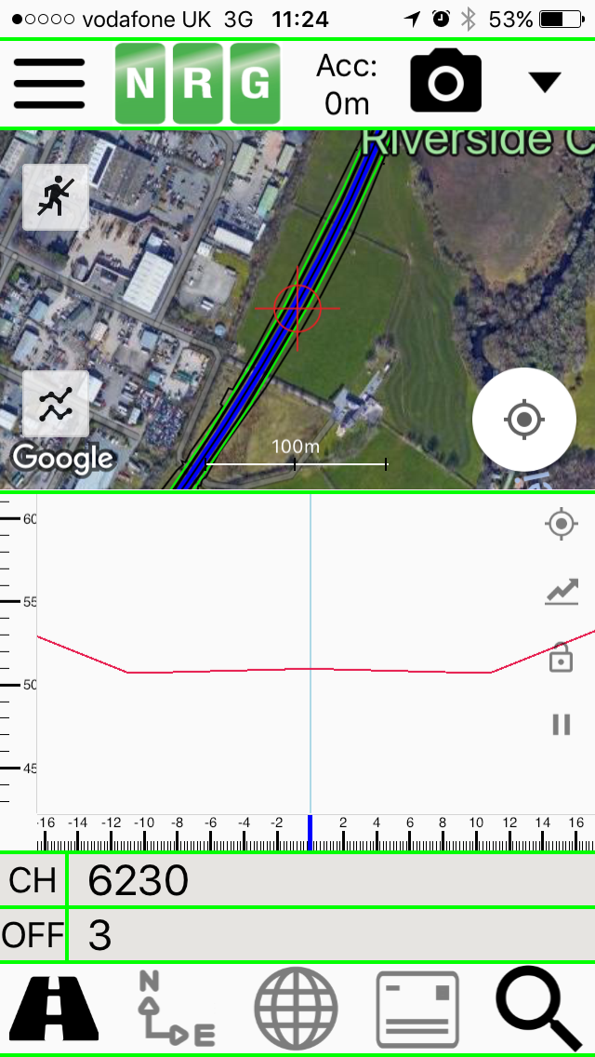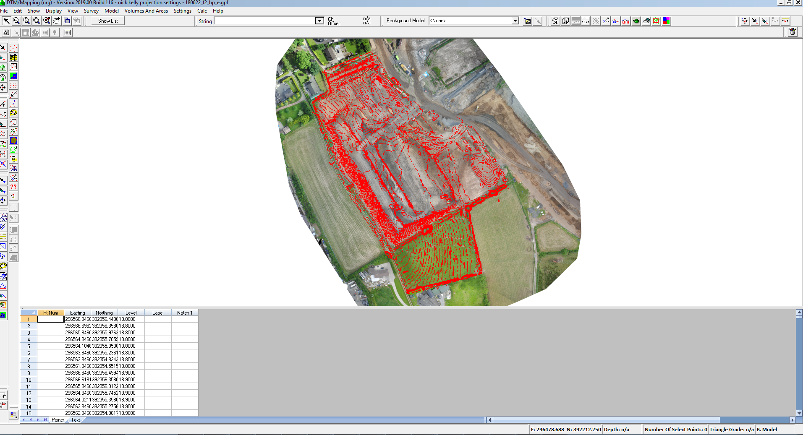

As usual we have added more tools to help with earthworks measures

 |  | Page
Mobile | Alignment Viewer
 | Scale Factor
 | Picture Mapper Mobile
 | Picture Mapper Pro
DTM Map | Long Sections | 3
 | River Sections | 3
 | Sightlines | 4
 | Add line by section | 4
 | Lift surfaces from background | 5
 | Volume of a surface | 5
 | Volume within a polygon | 5
 | Batch volume | 5
 | Perpendicular dips in volumes | 5
 | Add point by gradient in CoGo | 6
 | Georeferenced images in background | 6
Monitoring | Automatic resections | 7
 | Google background
 | Movement circles
NRGWIN | Projects

Alignment Viewer

Download the App from the google play store or iTunes for your mobile device

Load alignments from XML files and NST files, load models from XML files

- View Chainages along an alignment of your devices position
- Take pictures and add watermark for Chainage
- Add pins
- View cross sections
- View section through google heights

Picture Mapper

Picture Mapper Mobile is a free app for your mobile device which allows you to add attributes to photo’s

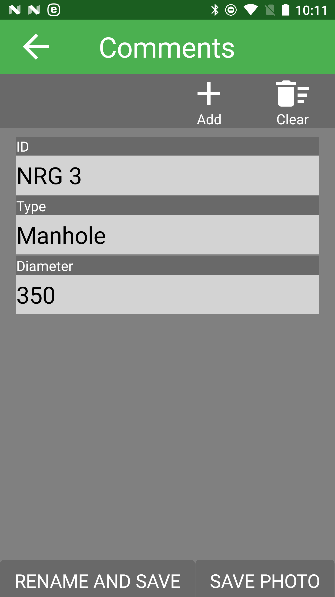

Picture Mapper Pro is a PC application for managing and reporting on the attributes stored with each picture. It uses the direction and distance stored with the picture to show the object position as well as the camera position

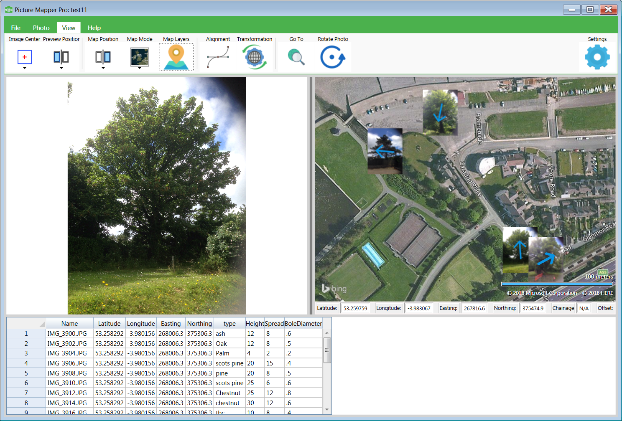
Page 2

NRG 2018

Reporting on each picture is done by setting up a template in word so that it inserts any of the attributes that you choose

The layout is entirely customizable and can automatically add a location plan using online maps and sets it to whatever scale you choose

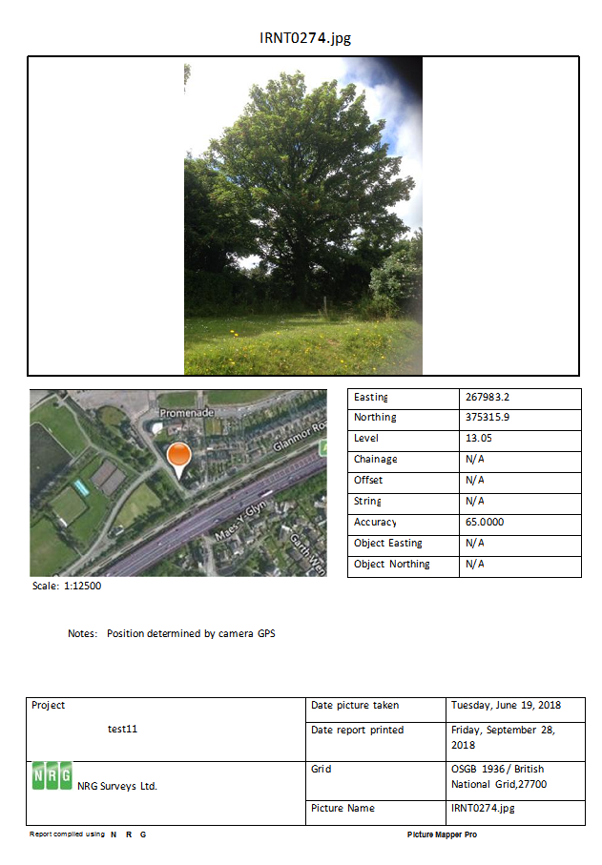

Scale Factor

This is a free app we find useful for getting the scale factor at the current position. It is also handy for finding out the postcode and by typing in a position converts coordinates to each of the systems

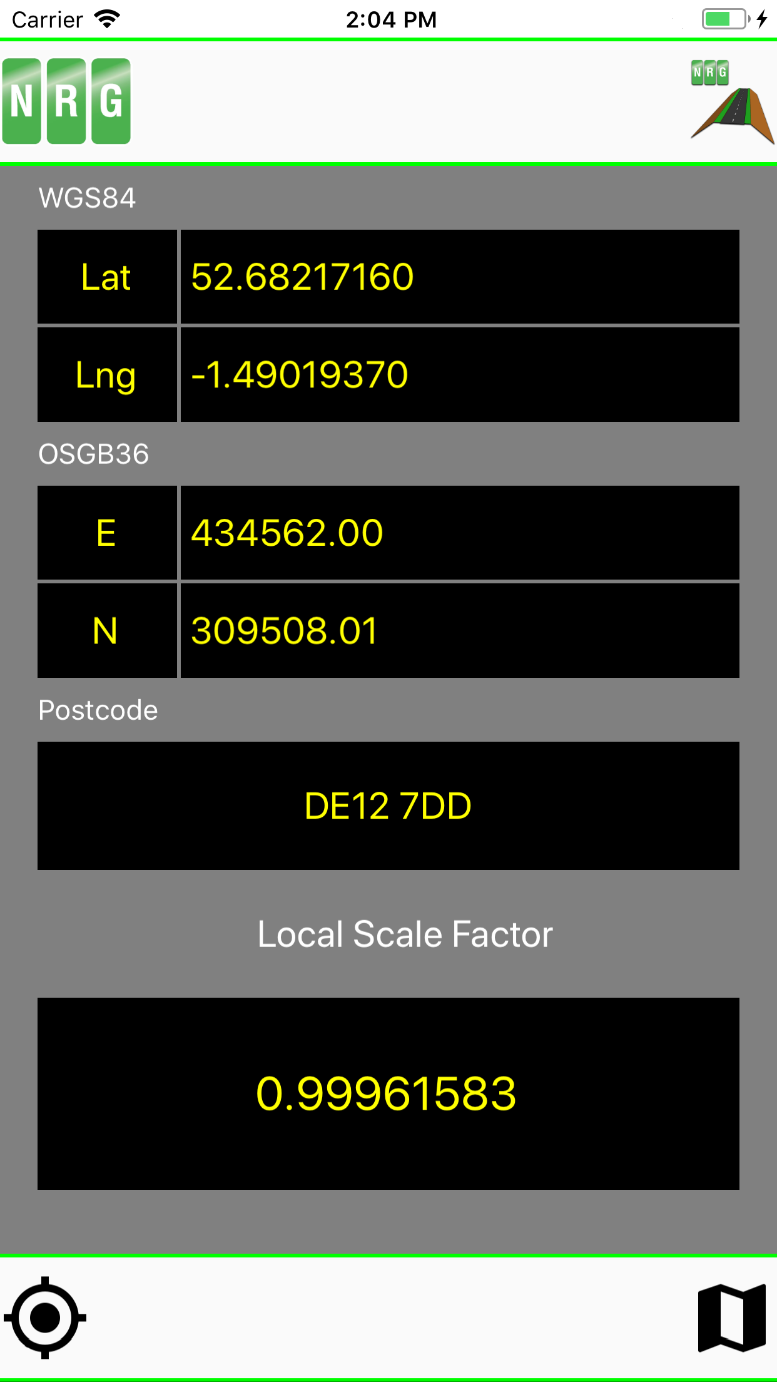

Long Sections

The long sections options have now been merged into one easy to follow wizard

Choose whether to follow a line or an alignment
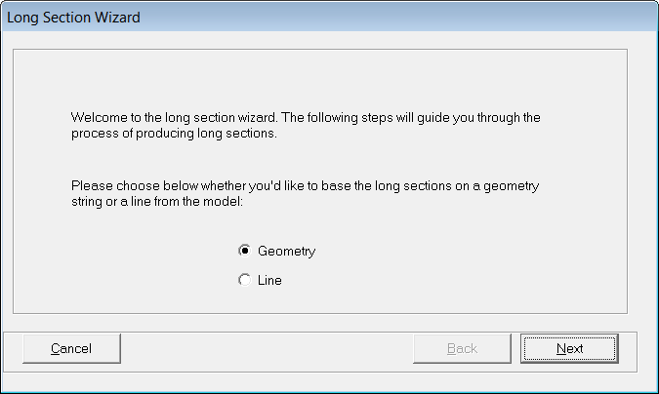

Pick additional lines using the tools provided

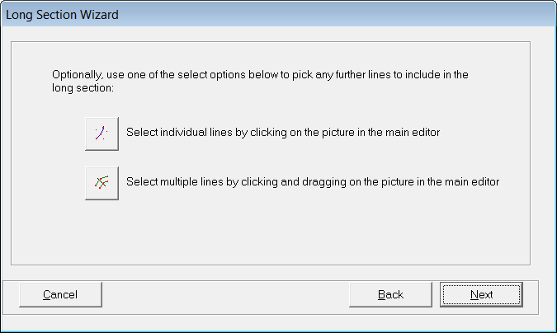

Include background models

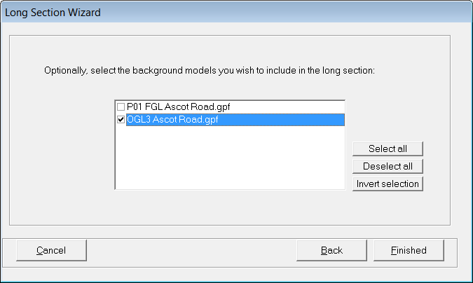

Preview the section then select, File, Print
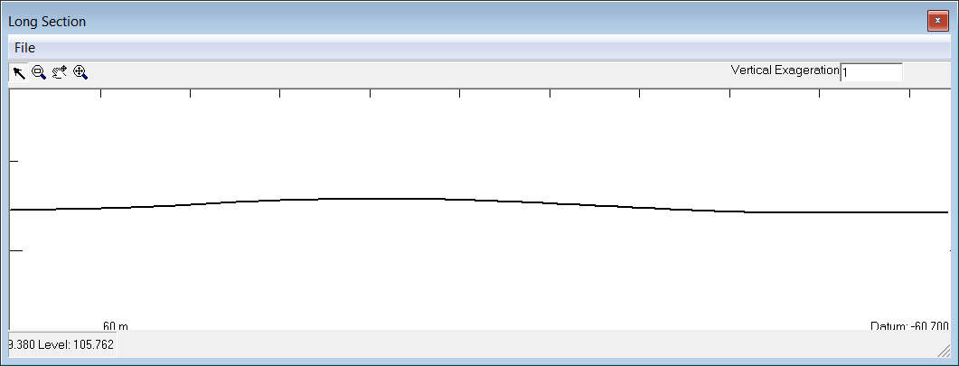

The print option allows you to set scales and add geometry etc. to the output

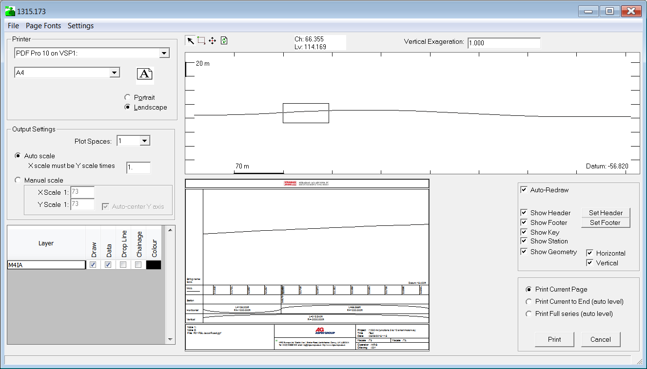
Long Sections Editor

Saving a section saves to a .LSC file which can be picked up in the new Long Sections editor

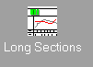

The long section files are now autonomous and no longer need to be stored with an alignment

When a long section is stored it will store all of the layers giving them the model or line names as layer names

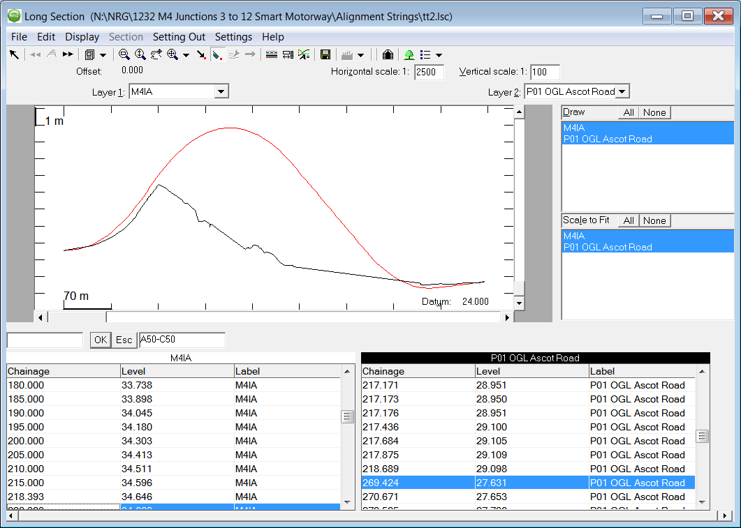

Edit points and lines and print etc. as in the cross sections editor

River Sections

To ease the production of sections where a model has not been formed or wouldn’t be appropriate we have added a ‘Gather Sections’ option

Gather section works much like dynamic sections except it lets you enter a sweep and gathers all of the points within that range. Save section has been updated to make it more user friendly

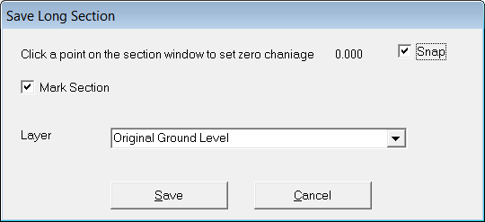

Page 3
NRG 2018

Page 4

Sight Lines

This new tool adds a shade area to the plan using dynamic sections

Edit, Shading, Shade by sight lines

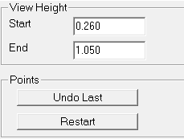

Set your start height and end height, then click on the map window where the start should be

Now drag the cursor around the plan to see a section with ‘cut’ and ‘fill’ shaded.

When you left click again on the map window it will add a shading point.

Right click to complete the shading

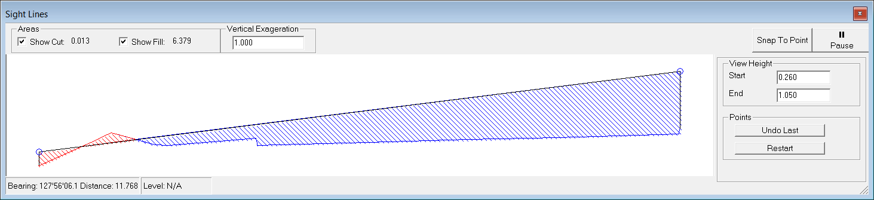

Add Line By Section

We put this is recently to help with designing pipework onto a model

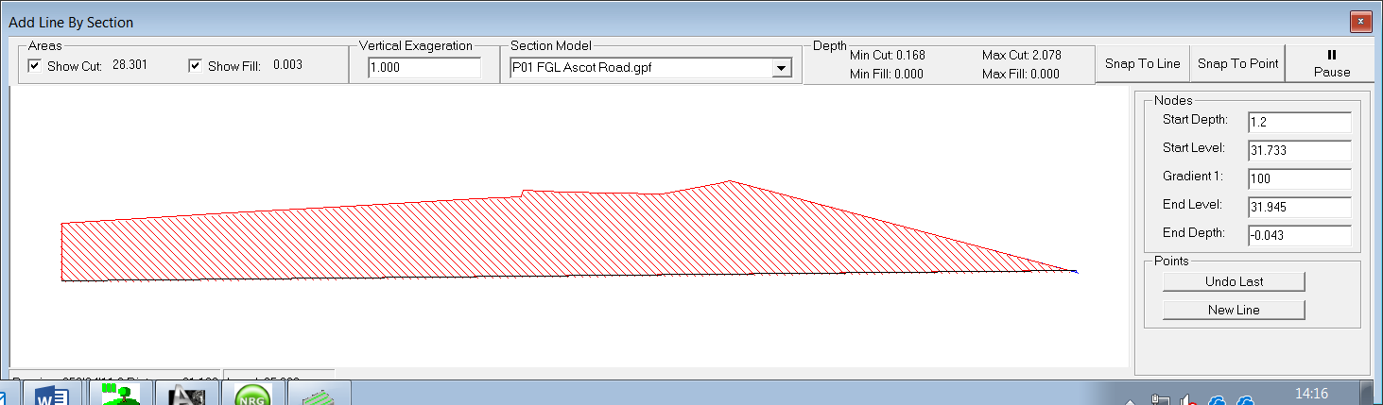

Edit, Lines, Add line by section

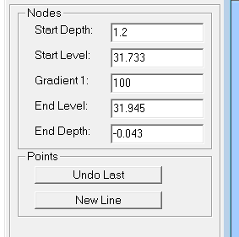

Enter a depth for the start node
Left click on the model to set the position for the start of the line and it will populate the level at that node.

Enter either an end depth or a gradient and move the cursor to the next node of the line and left click

This can then be repeated and when the entire line has been done right click and select a line style

NRG 2018

Page 5
NRG 2018

Import Surfaces within Polygon

Changes triangle surfaces to thos of a background only within a polygon

Edit, Triangles, Change Surfaces, Import within polygon

Left click to draw a polygon, right click to close

Select the background ( from the list of current background models ) and it will change the foreground model surfaces with that polygon for those in the background model

Volume of a Surface

This calculates and reports a volume of one surface against a background model. For instance you might have a berm surfaced up in the foreground model and want to know the volume against the background for just that berm

Volumes and Areas, Volume of surface. Left click inside the surface and it will go to the volume dialogue for selected triangles where you can make other choices such as applying dips, then press ok to report the volume

Volume Within Polygon

Volumes and Areas, Volume of Polygon

Left click and draw a polygon, right click and it will go to the volume dialogue where you can make other choices such as applying dips, then press ok to report the volume

Batch Volume

Calculates the volume for multiple models and puts each model as a zone in the volume report

Volumes and Areas, Batch Volume

You will be taken to the file dialogue where you can select multiple files then it will go to the volume dialogue for where you can make other choices such as applying dips, then press ok to calculate and report the volumes

Perpendicular dips in volumes

Probably long overdue but we have given the option in calculating volumes to apply the dips perpendicular to the triangles

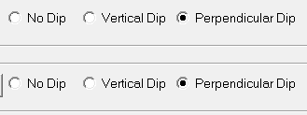

Page 6

NRG 2018

GeoReferenced Images

Many raster images have the ability to store georeferencing information so instead of having to rectify the image in our raster manager we have added a simple option to load a georeferenced image in background

File, Load, Geo-Referenced Image

Make sure you have Geo-Referenced Images selected in the ‘show’ menu and it will draw in background

Add Point by Gradient

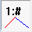 New function added in CoGo to calculate a new point on a line by entering a gradient from each point and it finds the intersection

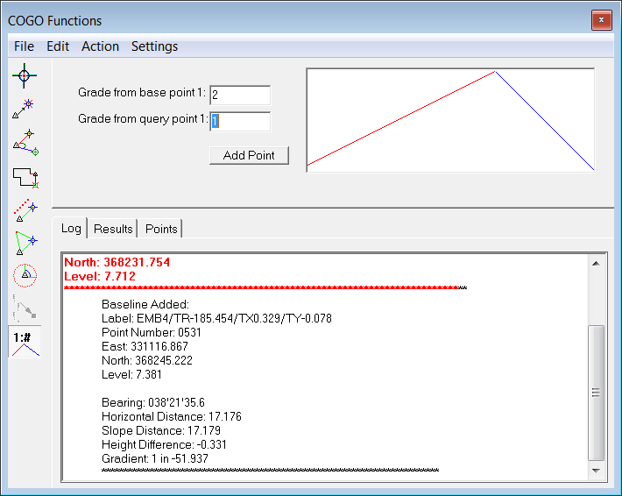

Page 7

NRG 2018

Road Design by IP

An intuitive and flexible way of creating and editing alignments and road designs

From the Calc menu select Road Design by IP

Horizontal

Curve details can be entered manually or graphically

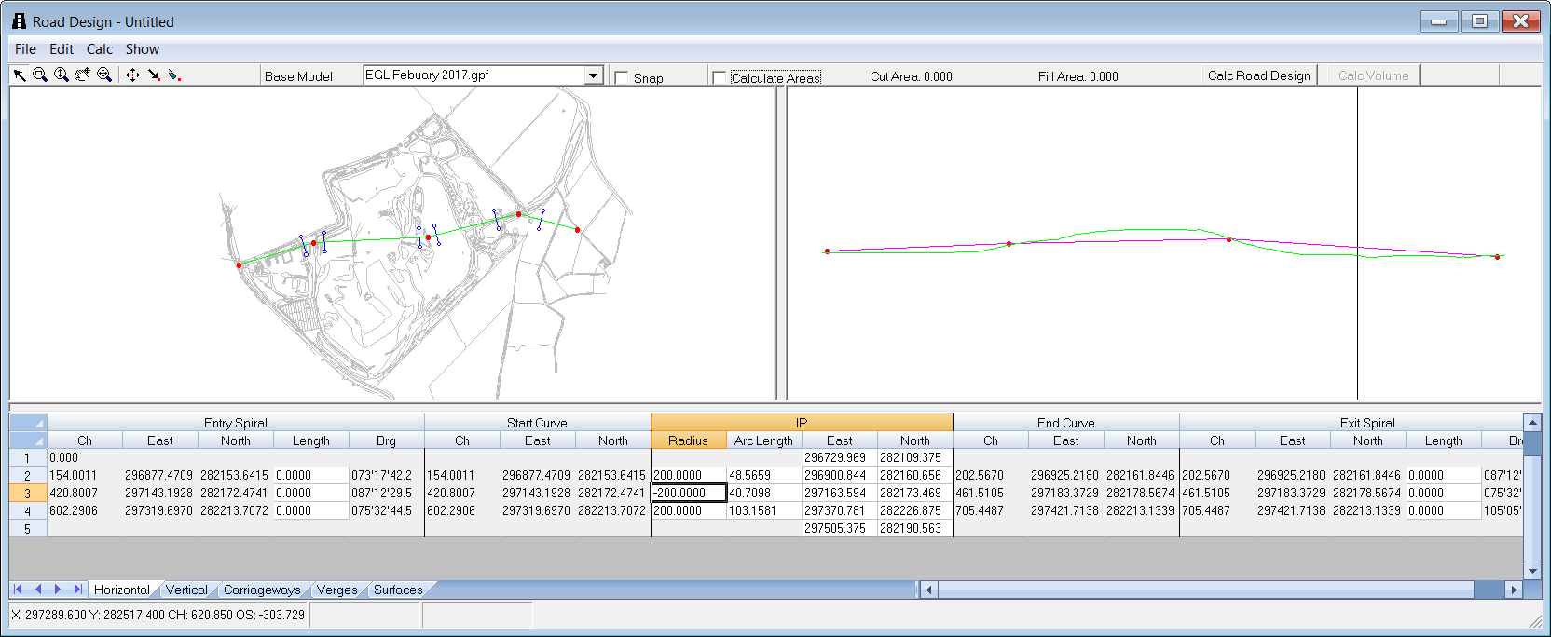

Vertical

The ground profile is used to fix the vertical alignment and cut / fill areas updated as the alignment is altered

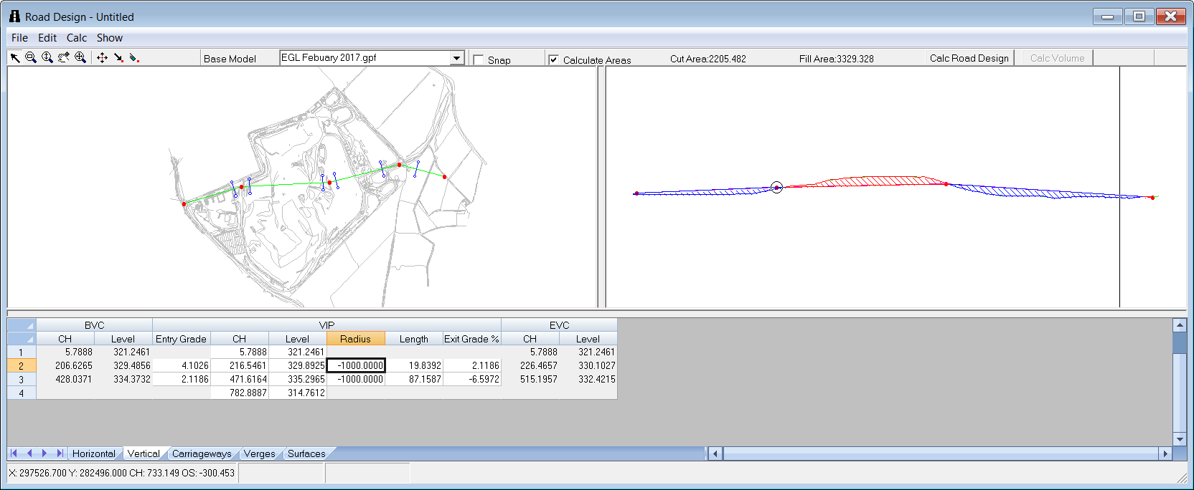

Carriageway

Gives you the opportunity to enter a table of crossfalls and road widths dependant on horizontal radius

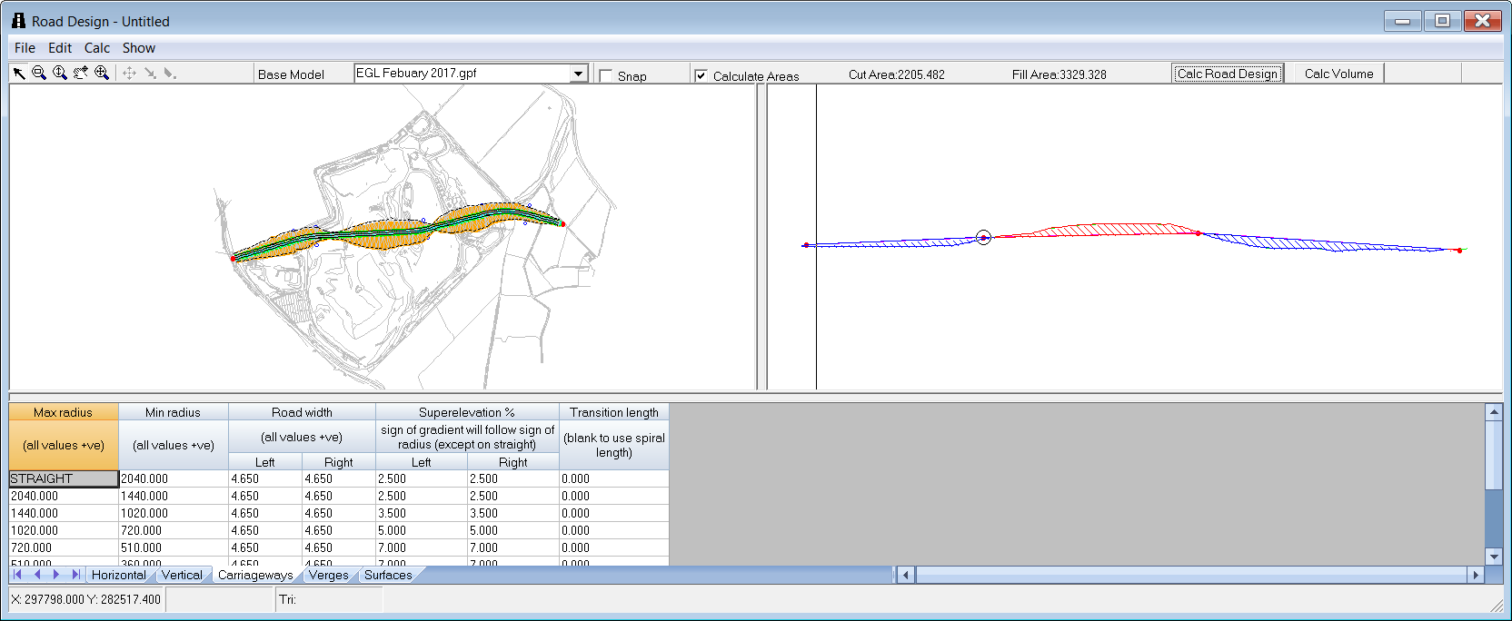

Verges

The Verges tab gives you the opportunity to tabulate verge and batter details against different heights of embankments or cuttings

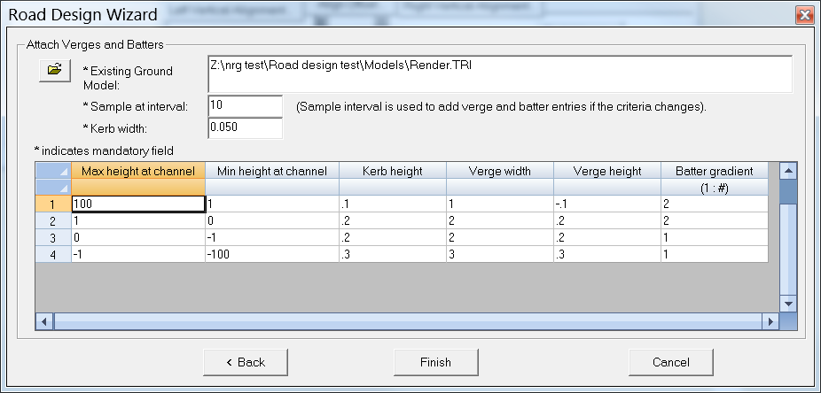

Press the Calc Road Design button will prompt for some extra detail such as chainage interval

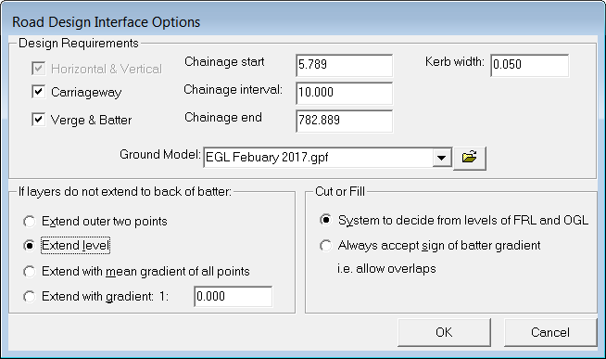

Calc Volume button calculates the volume so that you can iterate your designs easily before you use the save option which allows you to save the model and / or the road design parameters

You can even set up your surfaces and allow for construction depths

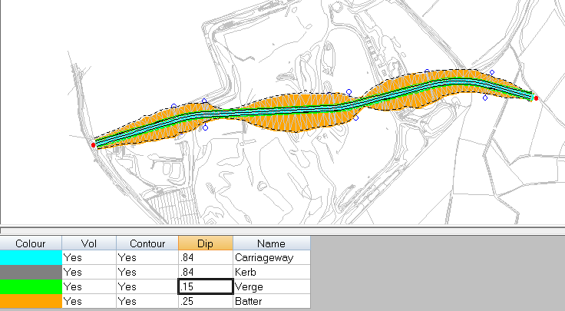

NRG 2018

Page 8

Area Shading on Sections

The ability to view and print different areas on a section has been added

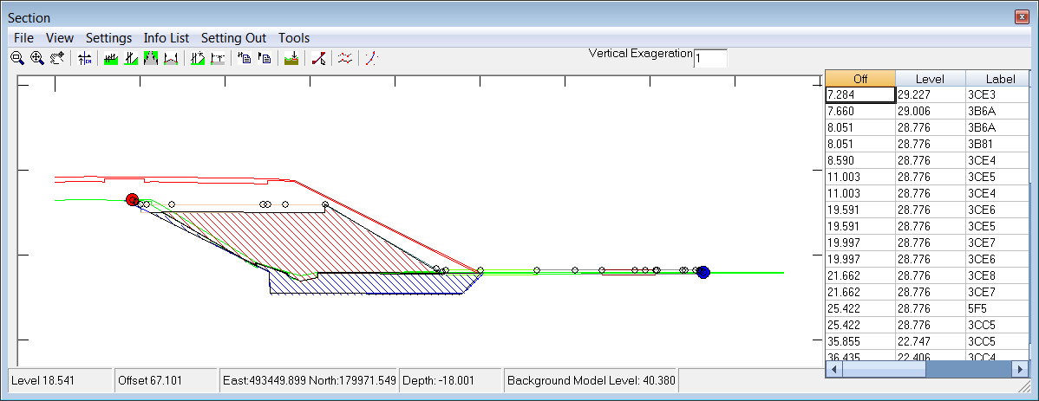

Draw a polyline around an area using the tools, area option, right clicking to close the polygon

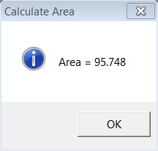The area will be displayed and you will be prompted for a colour

Use the mark section button to store details about the section

Use Tools, Edit Section mark to view areas, edit shading and remove them

Export DWG from drainage

Outputs a neat drawing showing pipes and inverts, gradients etc.

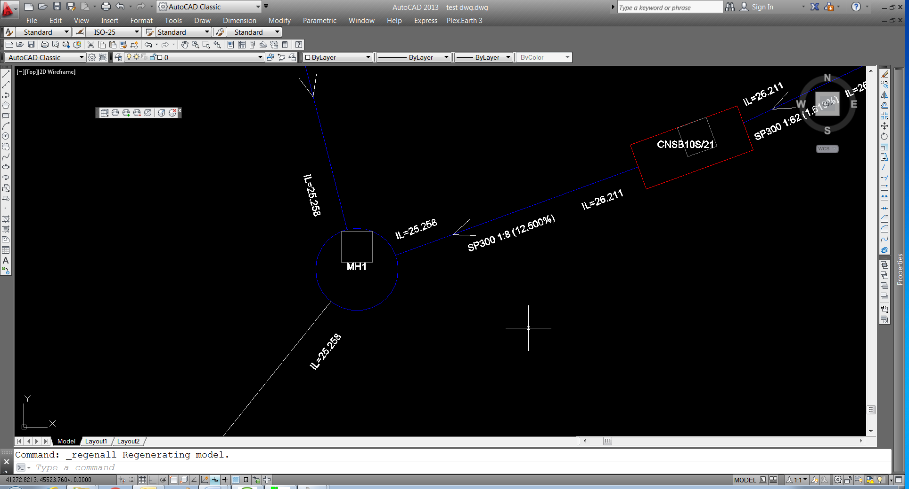

Sends it out in 3D showing pipes, trenches and manhole rings
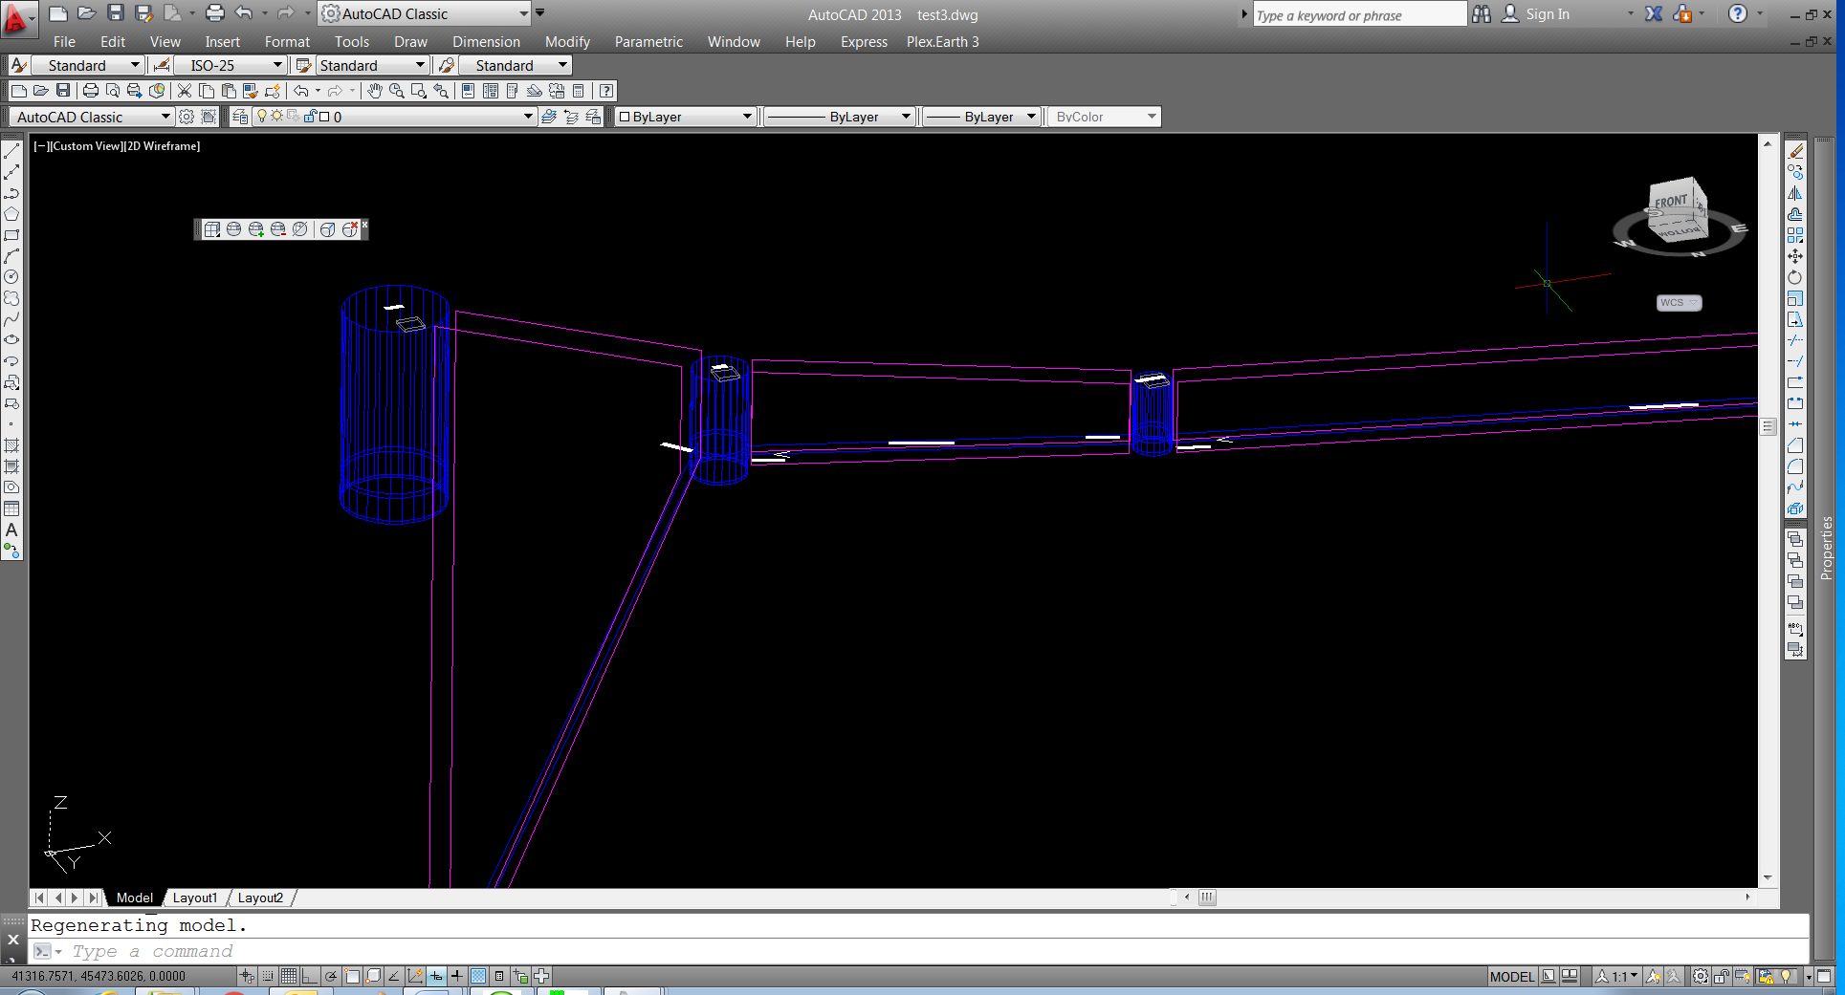

Acknowledgments

I would once again like to thank our many customers for their ongoing support, contributions and suggestions

In particular this year I would like to thank the customers whose suggestions and ideas have been incorporated into this year’s release

Adrian Hodgetts
Andy Clough
Bartosz Bazararowski
Darren Perkins
Dave Wallington
Dave Warren
Gavin Bill
Guy Roberts
Mark Lawton
Matt Twiss
Paul Howard
Paul Willson
Ruari McLeod

And of course I would like to thank our surveyors and programmers who have worked so hard for yet another release

Charlie Allardice
Charles Gersham
Dave Bosustow
Ed Stanyer
Ian Plummer

NRG Surveys
Castle View
Station Road
Llanfairfechan
Conwy
LL33 0AN

WWW.NRGSURVEYS.CO.UK

Practical Solutions to Technical Problems

